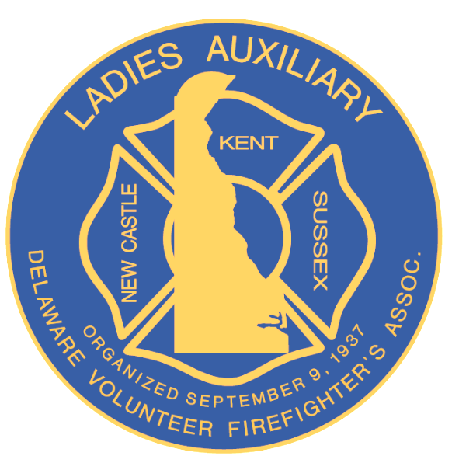

Ladies Auxiliary
Delaware Volunteer Firefighter’s Association

Par 3 Golf Tournament Hole Sponsor
September 25, 2025

Auxiliary or Business Name:

Contact Person: Phone Number:

Address:

Cost for Hole Sponsor is $50.00 each.

Please make all checks payable to DVFA Conference 2025

Please submit with completed sponsor form to:

Ladies Par 3 Golf Tournament Chairperson:

Barbara A. Rossiter
4 Prescott Drive – Varlano – Newark, DE 19702
Home: 1-302-737-3245 or Cell: 1-302-354-0645

Please Respond by July 15, 2025

